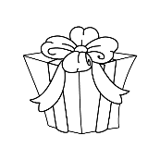
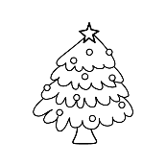
Do you celebrate Christmas? – Class survey
Name: ____________________________ Date:________________
Students use tally marks to record and interpret data.
Task: Ask each of your classmates the question “Do you celebrate Christmas?”
Record their answers on the chart.
Use tally marks to record the number of yes and no responses.
Write a sentence to explain what you found out.
My question:

Do you celebrate Christmas?

 | Yes | No
Enter name
Enter name
Enter name
Enter name
Enter name
Enter name
Enter name
Enter name
Enter name
Enter name
Enter name
Enter name
Enter name
Enter name
Enter name
 | Yes | No
Enter name
Enter name
Enter name
Enter name
Enter name
Enter name
Enter name
Enter name
Enter name
Enter name
Enter name
Enter name
Enter name
Enter name
Enter name
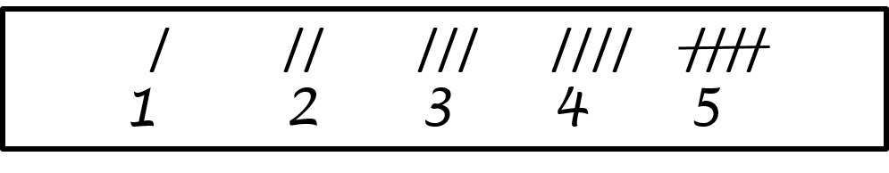

Tally your results here. Remember how to count tallies:
Yes
No

I found out that

