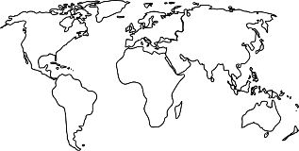
Our family’s traditions and celebrations
Child’s name: ___________________
Dear Parents,
Please discuss these items with your child as you complete the form.
Talk about the events, for example: where they are held, special clothes that are worn, foods that are eaten, activities engaged in.
Please write legibly so that your child can read what you have written.
A photograph to support each piece of information would be wonderful, but not essential.

Our family’s cultural heritage is ____________________________.
Special celebrations in our culture:
________________________________________________________
________________________________________________________
________________________________________________________
________________________________________________________
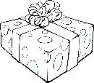
________________________________________________________

Special events we celebrate in our family:
(Note: some of these may be the same as, and some different from those listed above as cultural celebrations.)
________________________________________________________
________________________________________________________
________________________________________________________
________________________________________________________
________________________________________________________
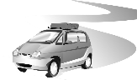
Our family’s favourite holiday:
________________________________________________________
________________________________________________________
________________________________________________________
________________________________________________________
________________________________________________________
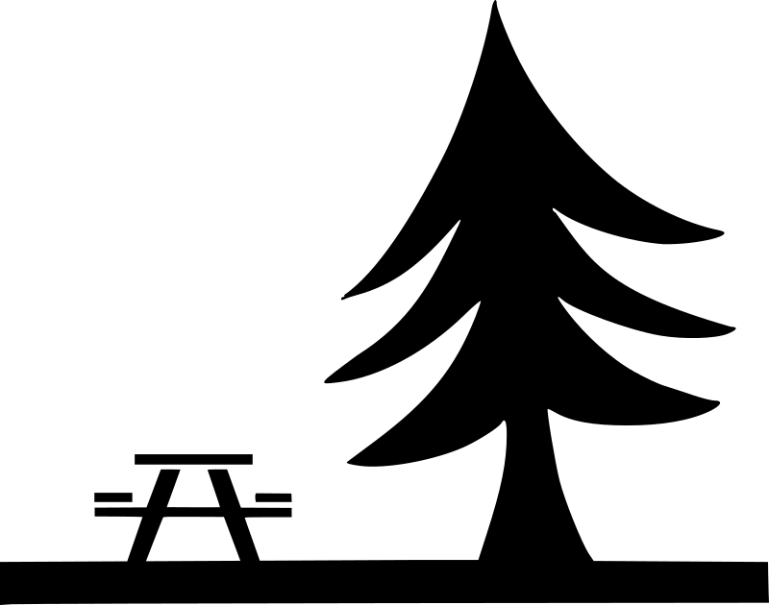
Our family’s favourite whole family activity:
________________________________________________________
________________________________________________________
________________________________________________________
________________________________________________________
________________________________________________________
Our family’s favourite game:
________________________________________________________
________________________________________________________
________________________________________________________
________________________________________________________
________________________________________________________
Our family’s favourite story:
________________________________________________________
________________________________________________________
________________________________________________________
________________________________________________________
________________________________________________________
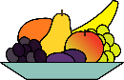
Our family’s favourite food:
________________________________________________________
________________________________________________________
________________________________________________________
________________________________________________________
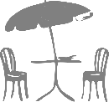
________________________________________________________

Our family’s favourite place to eat:
________________________________________________________
________________________________________________________
________________________________________________________
________________________________________________________
________________________________________________________
Something else our family likes:
________________________________________________________
________________________________________________________
________________________________________________________
________________________________________________________
________________________________________________________

