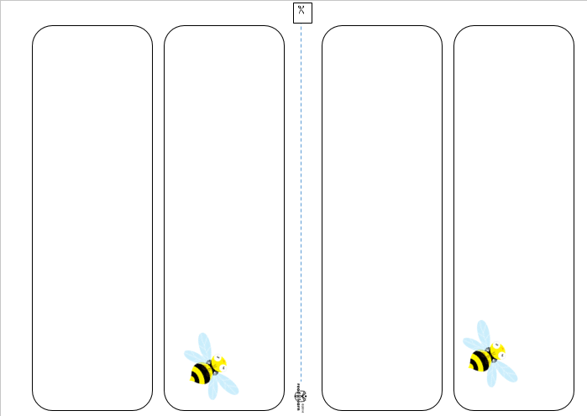

First name

First name

First and last name

First and last name